INDIAN SCHOOL AL WADI AL KABIR
Post Mid Term Examination 2022-23
SUB: Science (086)
Date: 29 /11/2022 Time Allowed :3 hour
Class: IX Maximum Marks: 80
General Instructions:
i. This question paper consists of 39 questions in 5 sections.
ii. All questions are compulsory. However, an internal choice is provided in some questions. A student is expected to attempt only one of these questions.
iii. Section A consists of 20 objective type questions carrying 1 mark each.
iv. Section B consists of 6 Very Short questions carrying 2 marks each. Answers to these questions should in the range of 30 to 50 words.
v. Section C consists of 7 Short Answer type questions carrying 3 marks each. Answers to these questions should in the range of 50 to 80 words
vi. Section D consists of 3 Long Answer type questions carrying 5 marks each. Answer to these questions should be in the range of 80 to 120 words.
vii. Section E consists of 3 source-based/case-based units of assessment of 4 marks each with sub-parts
SECTION - A
Select and write one most appropriate option out of the four options given for each of the
questions 1 – 20
Q. No | Questions | Marks
1 | The melting point of ice on Kelvin scale is :  - 273 K b. 0 K  - 373 K d.100 K | 1
2 | Tincture of iodine has antiseptic properties. This solution is made by dissolving  a. Iodine in potassium iodide b. Iodine in vaseline  c. Iodine in water d. Iodine in alcohol | 1
3 | Blood and sea water are  a. both mixtures  b. both are compounds  c. blood is a mixture whereas sea water is a compound  d. blood is a compound and sea water is a mixture | 1
4 | Which of the following elements is not a metalloid?  a. Boron b. Silicon  c. Germanium d. Tungsten | 1
5 | If the humidity in the air increase then the rate of evaporation:  a. Decrease b. Increase  c. Remain same d. Both (a) and (b) | 1
6 | Gases do not have:  a. High compressibility b. High fluidity  c. High density d. Large volume | 1
7 | Which of the following has the strongest interparticle forces at room temperature?  a. Oxygen b. Water  c. Bromine d. Iron | 1
8 | In summers, leaves of a potted plant droops when the soil becomes dry. Which cell organelle makes the leaves to droop?  - Nucleus, as it stops making DNA.  - Cell wall, as it starts to shrink.  - Lysosome, as it is releasing the digestive enzymes.  - Vacuole, as it loses all the water. | 1
9 | Anil has bacterial infection. Which part of the cell will help him eliminate bacteria from his body and how?  - Vacuoles as they can uptake any material and store it.  - Vacuoles as they can expel substance out of the cell.  - Lysosomes as they have digestive enzymes to breakdown foreign material.  - Lysosomes as they can destroy their own cell. | 1
10 | Muscles that are present in the eye helps the eyelids to blink when dust particles enter the eye. Which animal tissue signals the muscles in the eyelid to blink?  - connective tissue  - epithelial tissue  - muscular tissue  - nervous tissue. | 1
11 | 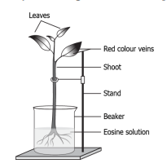  The image shows a setup of an experiment.  A student takes a leafy green Balsam plant and places it in Eosin solution. The solution is a red-coloured dye. After 4 hours, the student observes that the red colour appears on the parts of the plant body. Which type of tissue is responsible for these changes?  - xylem as it helps in the movement of water from roots to stem and leaves  - phloem as it helps in the movement of water from roots to stem and leaves  - xylem as it helps in the movement of water from leaves to roots and stem  - phloem as it helps in movement of water from leaves to roots and stem | 1
12 | The increase in food grain production after the introduction of improved varieties of crops is often referred as ..........  - White Revolution  - Green Revolution  - Yellow Revolution  - Blue Revolution | 1
13 | Sita is enjoying a ride on a merry-go-round which is moving with a constant speed of 15m/s. It implies that Sita is  - at rest  - moving with no acceleration  - in accelerated motion  - moving with uniform velocity | 1
14 | The image shows the force acting on a block. The length of the arrow shows the strength of the force and the direction of the arrow shows the direction of application of the force  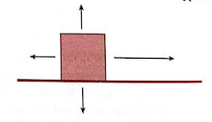  What is the direction of the resultant force?  a. Downwards b. Upwards  c. Towards left d. Towards right | 1
15 | A marble of mass “m” at rest is pushed with force “F” it starts travelling with velocity “v” in time “t”. Which option correctly relates the force with change in momentum?  a. F= (vt/m) b. F= (mv/t) c. F=(mt/v) d. F= (mvt) | 1
16 | The image shows a model of earth with mass m1 and its moon with mass m2.  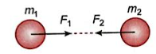  Based on the model, what should be the magnitude of forces F₁ and F₂ in accordance with the Newton’s third law of motion?  a. F₁ = F₂ b. F₁ > F₂  c. F₁ < F₂ d. F₁ = -F₂ | 1
Q. no 17 to 20 are Assertion - Reasoning based questions. These consist of two statements – Assertion (A) and Reason (R). Answer these questions selecting the appropriate option given below: (a) Both A and R are true and R is the correct explanation of A
(b) Both A and R are true and R is not the correct explanation of A
(c) A is true but R is false
(d) A is False but R is true
17 | Assertion(A): Atom is electrically neutral.  Reason(R): Equal number of protons and electrons are present in an atom. | 1
18 | Assertion (A): Fodder crops like berseem, oats, etc. are also grown along with cereals and pulses.  Reason(R) : Fodder crop is food for the livestock. | 1
19 | Assertion (A): The outer membrane of mitochondria is folded into cristae.  Reason(R) : Cristae increases the surface area. | 1
20 | Assertion(A): An object immersed in a liquid weighs more.  Reason (R) : Upward buoyant force acts on an object immersed in the liquid making it weigh less. | 1
SECTION – B
Q. no. 21 to 26 are very short answer questions
21 | Identify the elements and compounds from the following substances:  Sulphur, water, Carbon dioxide, Neon, air, soil  OR  Why does our palm feel cold when we put some acetone or perfume on it? | 2
22 | Write two features of plant cell which provide them with strength and rigidity. | 2
23 | Briefly describe the structure and any one function of Golgi apparatus. | 2
24 | Write two functions of areolar connective tissue. | 2
25 | a. A person holds a bundle of hay over his head for 30 minutes and gets tired. Has he done some work or not? Justify your answer.  b. Write an expression for the work done when a force is acting on an object in the direction its displacement.  OR  a. List two conditions which need to be satisfied for the work to be done on an object.  b. A girl is running along a circular path with a uniform speed. How much work is done by the girl? | 2
26 | How are simple tissues different from complex tissues in plants? (one point for each) | 2
SECTION - C
Q.no. 27 to 33 are short answer questions.
27 | What is a shell or orbit? Write and draw the distribution of electrons in Carbon atoms | 3
28 | a) Differentiate between a true solution and a colloid (2 points).  b) What is Tyndall effect? | 3
29 | Write any three differences between voluntary and involuntary muscles.  OR  - Identify the following diagram and label the parts A and B.  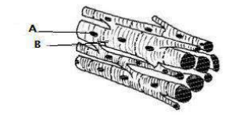  - What type of muscle cell is this?  - Mention any characteristic feature of given muscle cell. | 3
30 | Define acceleration due to gravity. Give two differences between acceleration due to gravity(g) and universal gravitation constant(G). | 3
31 | Identify the following graphs and answer the questions.  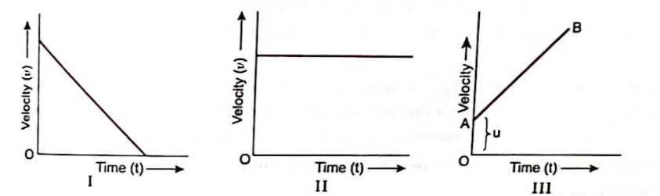  a. What do you infer from the graph where velocity time graph is parallel to the time axis?  b. Which of the graphs indicate negative acceleration? Why?  c. Which of the graphs represent a body moving with initial velocity not equal to zero but with constant acceleration?  OR  Given below is the velocity- time graph for the motion of the car. What does the nature of the graph show? Also find the acceleration of the car.  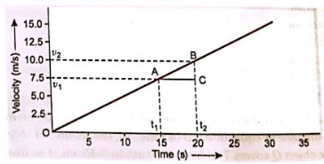 | 3
32 | State Newton’s second law of motion. Using Newton’s law of motion, derive the relation between force and acceleration. | 3
33 | Why is crop variety improvement important in crop cultivation? Describe any two important factors for which variety improvement is done. | 3
SECTION - D
Q.no. 34 to 36 are Long answer questions.
34 | a. What is matter? Write any two properties of solids and liquids.  b. Name A, B, C, D, E and F in the following diagram showing a change in its state.  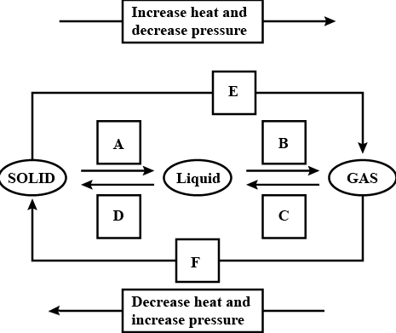  OR  a. What is evaporation? Explain the factors affecting evaporation.  b. Convert the following into degree Celsius.  i) 573K ii) 363K | 5
35 | - Draw a neat labelled diagram of the section of the tissue that transports food in plants.  - Briefly explain the formation of bark. What makes it impervious to water?  OR  - With the help of a neat, labelled diagram write the importance of nerve cells in animals.  - Explain briefly the structure of any two types of epithelial tissue (any one feature) and also state their functions. (any one function) | 5
36 | a. State the universal law of gravitation.  b. Derive expression for force of attraction between two bodies  c. What will happen to the gravitational force between two bodies if the masses of one body is doubled?  d. A stone is dropped from a cliff. What will be its speed when it has fallen 10 m. (Take g= 9.8m/s²) | 5
SECTION – E
Q.no. 37 to 39 are case - based/data -based questions with 2 to 3 short sub - parts. Internal choice is provided in one of these sub-parts.
37 | A teacher asked a group of students to heat a given sample of ice and to draw a heating curve representing temperature rise as a function of heat added. After performing experiment at one atmospheric pressure, the students gave the following curve  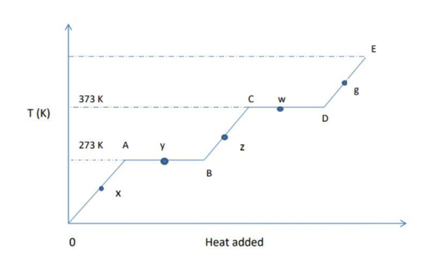  Write the correct answer in each of the following questions:  (i) What is the physical state of substance at point y?  (a) Ice only  (b) Water only  (c) Ice and water coexist  (d) Ice and vapour  ii) Define melting point.  iii) The melting points of three solids X, Y, Z are 298K ,314K, 398 K respectively. Arrange these in increasing order of their inter particle force of attraction. Justify your answer?  OR  iii) Which of the following two will give you more severe burns and why?  a) Steam at 373K b) Water at 373K | 4
38 | India is a country with three fourth of the population engaged in agriculture. Different crops require different climatic conditions, temperature and photoperiods for their growth and completion of their life cycle. Photoperiods are related to the duration of sunlight. Growth of plants and flowering are dependent on sunlight. Even though financial conditions of some farmers do allow them to take higher level farming practices and improved agriculture technology, yet they are hesitant to use HYV. Scientific management practices should be undertaken to obtain high yields from farms. For sustained livelihood, one should undertake mixed farming, intercropping, and integrated farming practices. it is important that we should increase food production without degrading our environment and disturbing the balances maintaining it.  - What is meant by genetically modified crops?  - What is sustainable management practices?  - Name the environmental factors related to cultivation practices and crop yield. Explain how are they related to crop yield?  OR  Differentiate between two crops with examples which are grown in different seasons or different climatic conditions. | 4
39 | If a block of wood measuring one cubic centimeter (1 cm x 1 cm x 1 cm) is placed in a container of water, the amount of water displaced will equal the weight of the block of wood. But what about if a block of the same size is made of lead? Lead has a much higher density than wood. If a one cubic centimeter block of lead is placed in a container of water, the amount of water displaced will equal the weight of the block of lead.  In the case of the wood, the weight of the water displaced is small. The buoyant force is greater than the gravitational force, so the wood floats. The lead is denser than the wood. That means it contains more mass in the same volume. So, more water is displaced by the lead than the wood. The gravitational force on the lead exceeds the buoyant force, so the lead sinks.  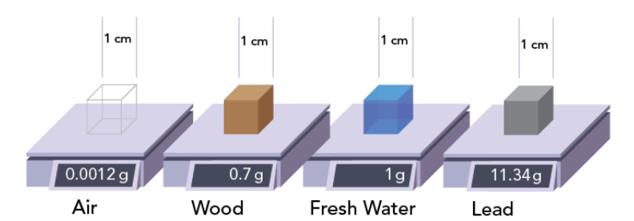  i. A cork released under water come up to the surface of water. Give reason.  ii. State Archimedes’ principle.  iii. An elephant weighing 50,000 N stands on one foot of area 0.1m². What is the pressure exerted on the ground?  OR  The volume of 50 g of a substance is 20 cm³.If the density of water is 1gcm^{–3}, will the substance float or sink? | 4

**********

